COMP 306- PROJECT REPORT

(Mehmet Çuhadar - Meryem Karakaş - Sinan Cem Erdoğan)

**1)Project Description**

We created student information management system for DU. In this system students can access all of the information about their academic lives, such as their current GPA, credits, course history, contact informations of their faculties, graduation status, instructor informations and schedule of their current courses. Beyond accessing their information they can add or drop courses. Students cannot add more than 5 courses and take less than 2 courses in a semester. Lastly, students can search available courses at the university.

**2) ER DIAGRAM**

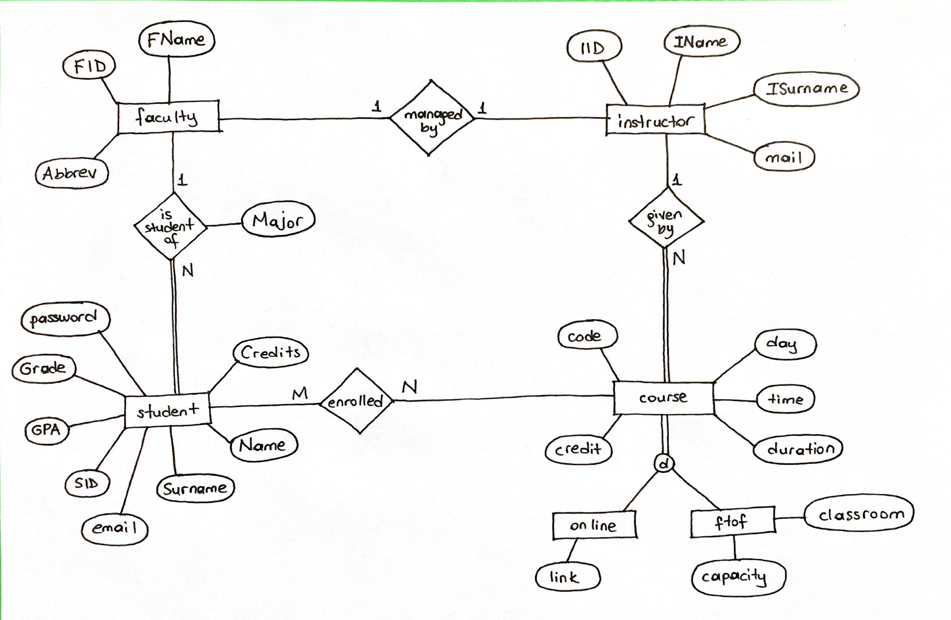

**3)**

CREATE TABLE instructor(

IID: int,

IName: varchar(20),

ISurname: varchar(20),

mail: varchar(100),

primary key(IID));

CREATE TABLE faculty(

FID: int,

Abbrev: varchar(4),

FIID: int,

FName: varchar(100),

primary key(FID),

foreign key(FIID) REFERENCES instructor(IID)

on update cascade on delete restrict);

CREATE TABLE student(

Name: varchar(20),

SUrname: varchar(20),

SID: int,

GPA: REAL,

Grade: int,

Credits: int,

email: varchar(100),

password: varchar(40),

SFID: int,

Major: varchar(50),

primary key(SID),

foreign key(SFID) REFERENCES faculty(FID)

on update cascade on delete restrict);

CREATE TABLE course(

Code: varchar(10),

Day: varchar(20),

Time: varchar(10),

Duration: int,

Credit: int,

CIID: int,

primary key(Code),

foreign key(CIID) REFERENCES instructor(IID)

on update cascade on delete restrict);

CREATE TABLE ftof(

FCODE: varchar(10),

Capacity: int,

Classroom: int,

primary key(FCODE),

foreign key(FCODE) REFERENCES course(Code)

on update cascade on delete restrict);

CREATE TABLE online(

OCODE: varchar(10),

Link: varchar(100),

primary key(OCODE),

foreign key(OCODE) REFERENCES course(Code)

on update cascade on delete restrict);

CREATE TABLE enrolled(

SSID: int,

CCODE: varchar(10),

Letter: varchar(3),

primary key(CCODE,SSID),

foreign key(SSID) REFERENCES student(SID)

on update cascade on delete restrict,

foreign key(CCODE) REFERENCES course(Code)

on update cascade on delete restrict);

**4)Data Sources**

We have seven tables, which are student,instructor,course,faculty,enrolled,ftof,online.

To populate the student table we generate names and surnames with online tools. For the rest of the attributes of the student table we used available formulas in excel and python to generate random majors.

To populate the instructor table,again, we generate names and surnames with online tools. For id and mail, we used excel properties and formulas.

To populate the course table, we identified the course names. Then, we used excel formulas to populate attributes of the table.

To populate the enrolled table, we used python for algorithms,which takes student grades and assigns courses and letters according to their grades.

To populate the ftof and online table, we used excel functions.

Finally, after creating the tables, we import these tables into database using data import wizard property of sql workbench.

**5)Complex SQL Queries**









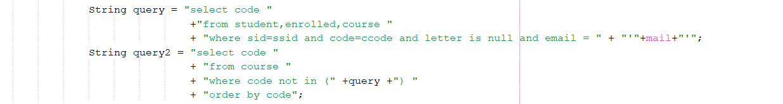

**6)Screenshots**

